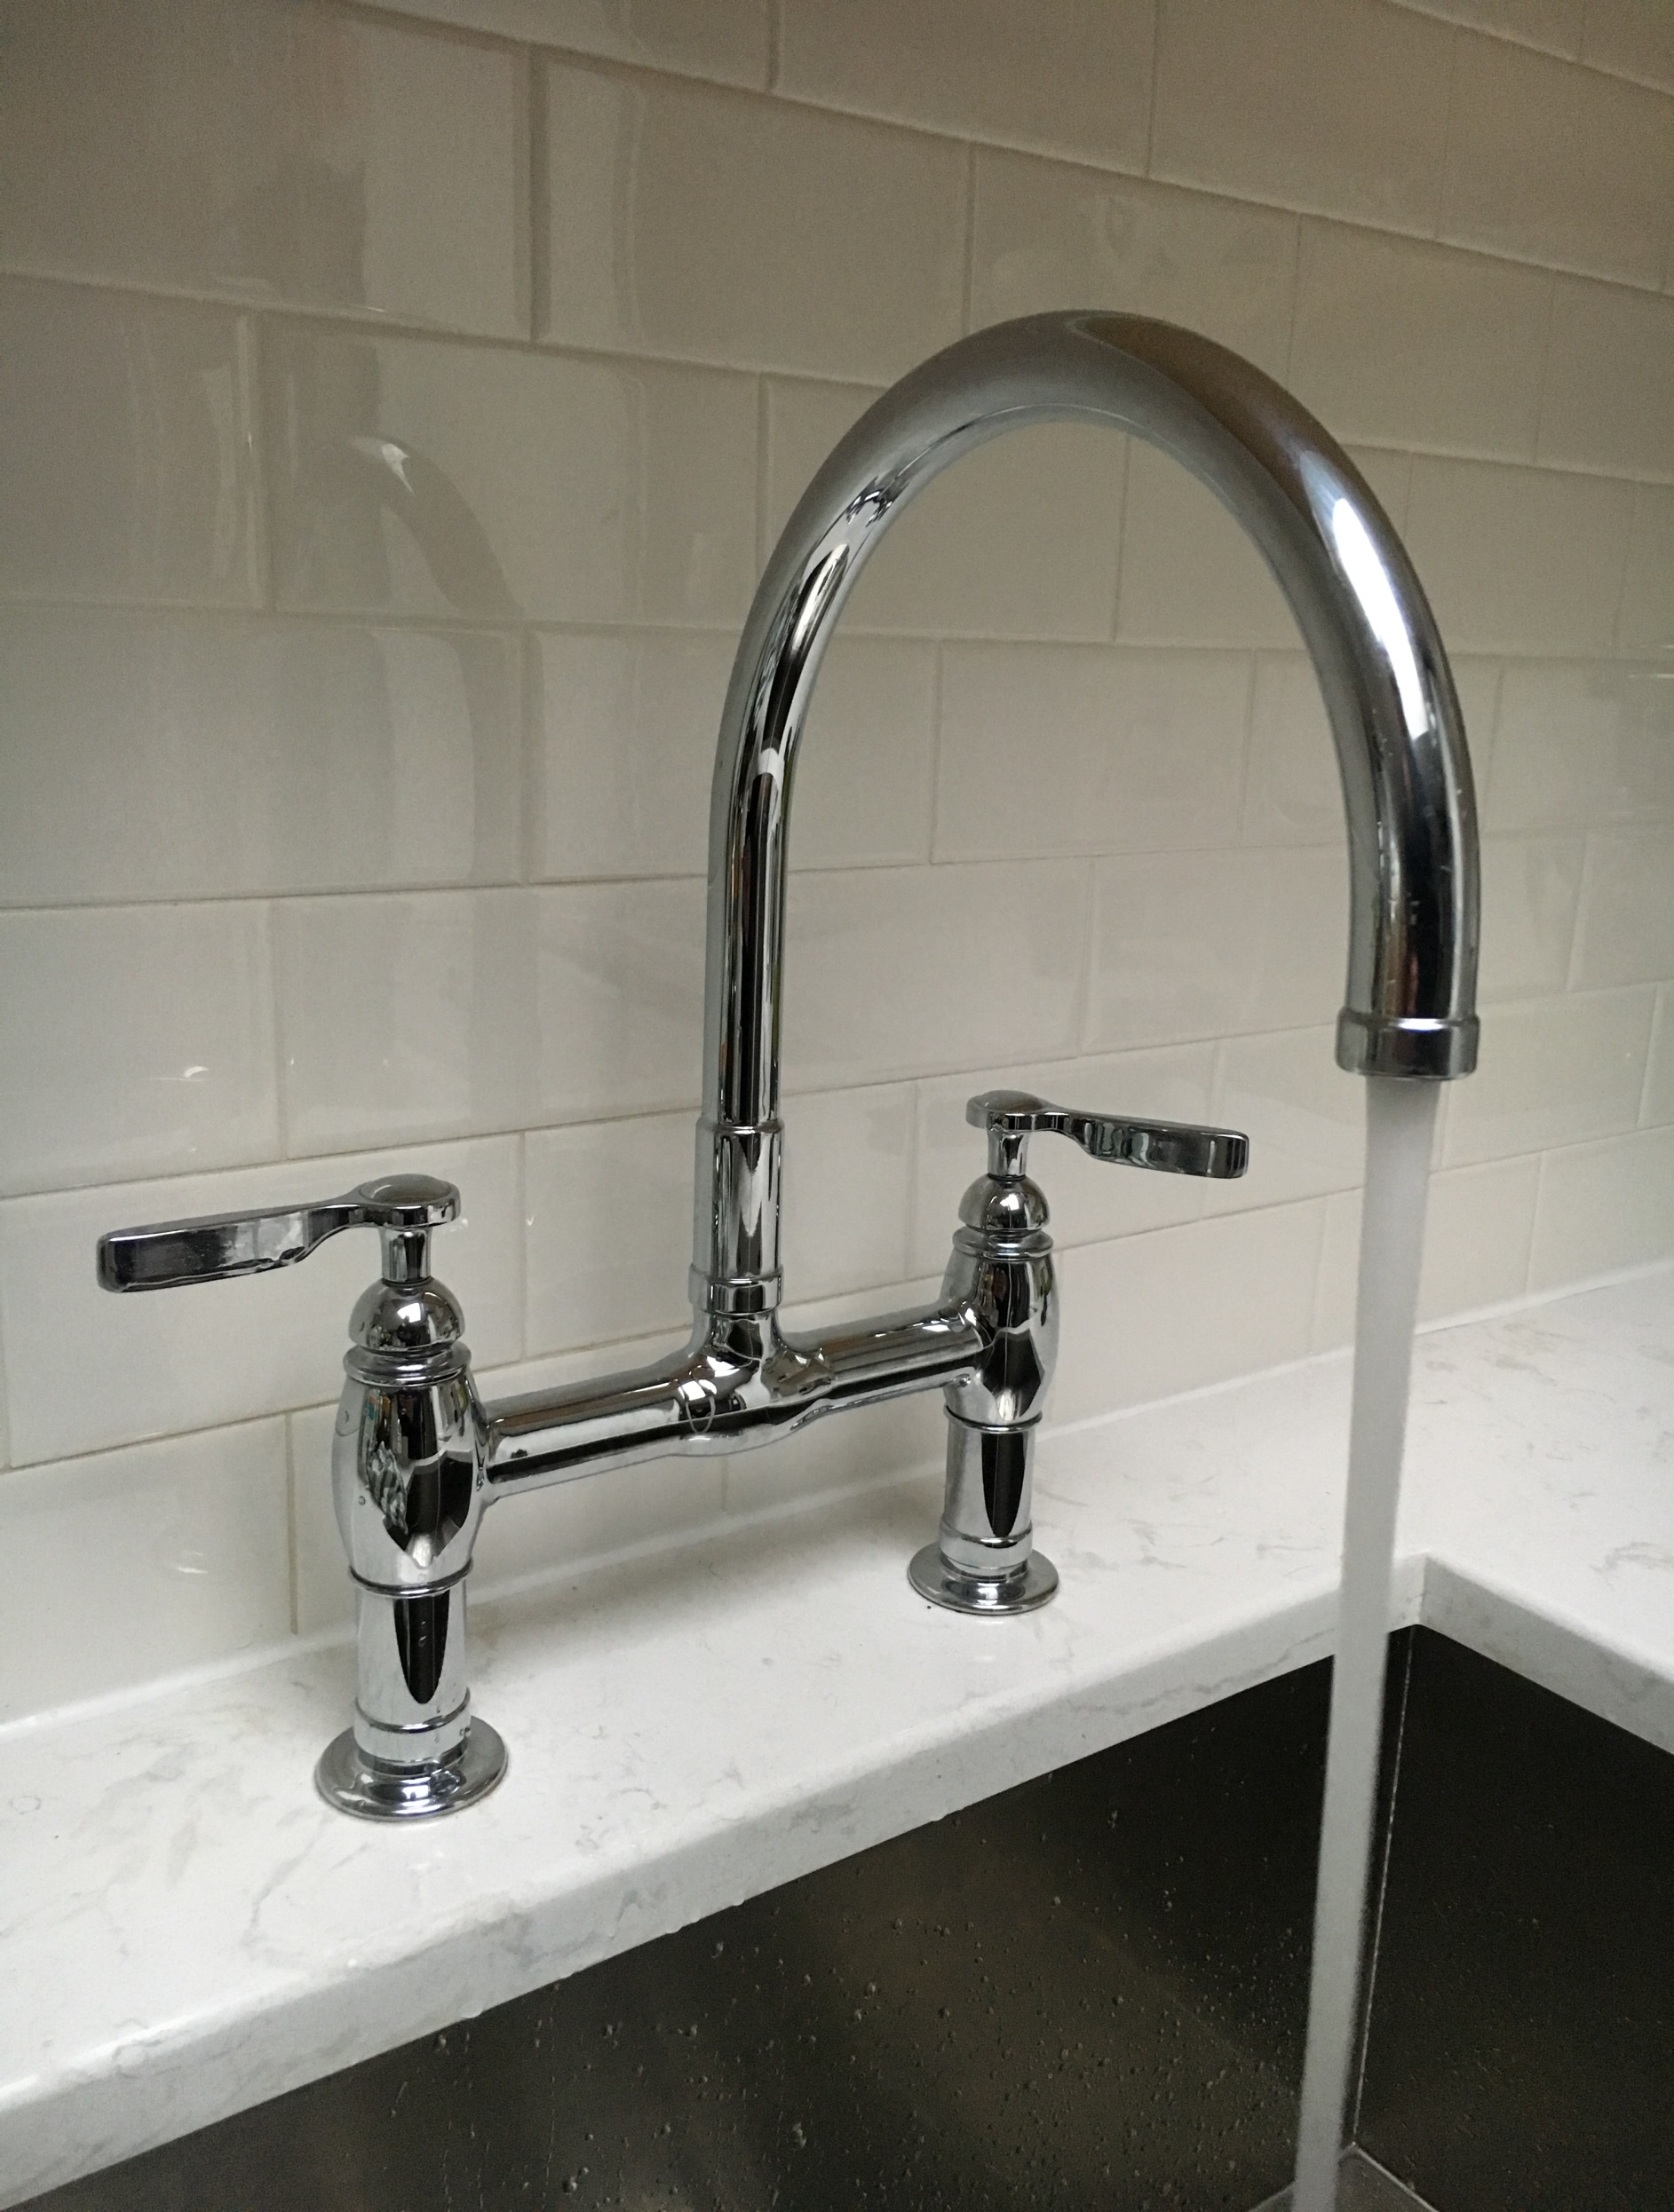

Government of the
Northwest Territories

Drinking

Water

Primer
2017

Drinking water in the Northwest Territories (NWT) goes through a number of treatment steps and tests to ensure that it is safe and of good quality. Community governments, the Government of the Northwest Territories (GNWT), and the water boards all play a role in ensuring that drinking water meets the requirements of the Water Supply System Regulations within the NWT Public Health Act. The Public Health Act adopts the Guidelines for Canadian Drinking Water Quality as the standard for treatment and sampling.

In the NWT, a multi-barrier approach is used to ensure drinking water safety. This approach includes source water protection, treatment processes such as filtration and disinfection, and regular sampling to verify that treatment is working properly. Community governments have primary responsibility for providing safe drinking water. Community governments are responsible for ensuring that trained staff treat and monitor the water on a daily basis. Various GNWT departments provide support, training, certification, operational funding, monitoring, and enforcement to support delivery of drinking water services.

Certified operators carry out the day-to-day operation of NWT water treatment plants. These operators have attended courses and passed an exam based on the level of complexity of the plant they operate. They are also required to maintain their certification with ongoing training and education. Operators are responsible for maintaining and cleaning their water plant, making adjustments to chemical dosages, and carrying out routine testing and monitoring for chlorine, turbidity, bacteriological quality. The results of all testing, along with the plant log sheets, are subject to review by the Environmental Health Officers at the GNWT Department of Health and Social Services. An additional suite of samples is taken annually to test for 28 chemical and physical parameters, such as pH, metals, dissolved and total solids, and color.

The GNWT has a website, www.nwtdrinkingwater.ca, which contains information for the public on the tests done on NWT drinking water, treatment processes, the roles and responsibilities of the communities and GNWT departments, and other frequently asked questions about drinking water. Questions or concerns about drinking water in a particular community should be directed to the water treatment plant operator in that community. If they cannot assist you, you can check for notices and announcements on the NWT Drinking water website.

Community  2017 Water Quality Summary – Table¹ | Plant Classification | Water Source | Water Treatment Process | Certified Operator | Treated Water  Chemical Tests  (1 required) |  |  | Treated Water Bacterial Tests  (48 Required)
 |  |  |  |  | 2017 | 2016 | 2017 |  | 2016
Aklavik | Class II | Mackenzie River (Peel Channel) | Conventional (Coagulation, Flocculation, Sedimentation and Filtration), Chlorination and Storage | ✓ | ✓ | ✗ | 61 |  | 60  0
Colville Lake* | Small System | Colville Lake | Cartridge Filtration, Chlorination, Storage | ✗ | ✓ | ✓ | 0 |  | 0
Délı̨ne | Small System | Great Bear Lake | Cartridge Filtration, UV, Chlorination, Storage | ✗ | ✓ | ✓ | 63 |  | 109
Behchokǫ̀ (Edzo) | Class II | West Channel | Conventional (Coagulation, Flocculation, Sedimentation and Filtration), Chlorination and Storage | ✓ | ✓ | ✓ | 69 |  | 219
Behchokǫ̀ (Rae) | Class II | Marian Lake | Conventional (Coagulation, Flocculation, Sedimentation and Filtration), Chlorination and Storage | ✓ | ✓ | ✓ | 55 |  | 61
Fort Good Hope | Class I | Mackenzie River | Membrane Filtration, Chlorination and Storage | ✗ | ✗ | ✓ | 98 |  | 27
Fort Liard | Class I | Groundwater Well | Potassium Permanganate Assisted Greensand Filtration, Softening, Chlorination and Storage | ✓ | ✓ | ✓ | 104 |  | 81
Fort McPherson | Class II | Deep Water Lake | Conventional (Coagulation, Flocculation, Sedimentation and Filtration), Chlorination and Storage | ✓ | ✓ | ✗ | 16 |  | 36
Fort Providence | Class II | Mackenzie River | Conventional (Coagulation, Flocculation, Sedimentation and Filtration), Chlorination and Storage | ✗ | ✓ | ✓ | 115 |  | 105
Fort Resolution | Class II | Great Slave Lake | Conventional (Coagulation, Flocculation, Sedimentation and Filtration), Chlorination and Storage | ✓ | ✓ | ✓ | 41 |  | 30
Fort Simpson | Class II | Mackenzie River | Conventional (Coagulation, Flocculation, Sedimentation and Filtration), Chlorination and Storage | ✓ | ✓ | ✓ | 58 |  | 72
Fort Smith | Class III | Slave River | Upflow Clarifier, Filtration, Chlorination, Fluoridation, Storage | ✗ | ✓ | ✓ | 65 |  | 71
Gamètì | Small System | Rae Lake | Chlorination | ✓ | ✓ | ✓ | 111 |  | 40
Hay River | Class II | Great Slave Lake | Conventional (Coagulation, Flocculation, Sedimentation and Filtration), Chlorination and Storage | ✓ | ✓ | ✓ | 114 |  | 72
Inuvik | Class III | Mackenzie River | Coagulation, Membrane Filtration , Chlorination, Fluoride, Storage | ✗ | ✓ | ✓ | 54 |  | 91
Jean Marie River | Class I | Mackenzie River | Membrane Filtration, Chlorination, and Storage | ✓ | ✓ | ✓ | 39 |  | 44
Łutselk’e | Class I | Great Slave Lake | Membrane Filtration, Chlorination and Storage | ✓ | ✗ | ✓ | 70 |  | 71
Nahanni Butte | Class I | Groundwater Well | Potassium Permanganate Assisted Greensand Filtration, Softening, Chlorination and Storage | ✓ | ✓ | ✓ | 68 |  | 103
Norman Wells | Class II | Mackenzie River | Conventional (Coagulation, Flocculation, Sedimentation and Filtration), Chlorination and Storage | ✓ | ✓ | ✓ | 140 |  | 76
Paulatuk | Small System | New Water Lake | Chlorination | ✓ | ✓ | ✓ | 36 |  | 37
Sachs Harbour | Small System | DOT Lake | Cartridge Filtration, Chlorination | ✗ | ✓ | ✗ | 32 |  | 15
Sambaa K’e | Class I | Trout Lake | Membrane filtration, Chlorination and Storage | ✗ | ✓ | ✓ | 48 |  | 32
Tsiigehtchic | Class I | Tso Lake | Nano-Filtration, Chlorination and Storage | ✗ | ✓ | ✗ | 52 |  | 80
Tuktoyaktuk | Class I | Kudlak Lake | Pressure Filtration, UV, Chlorination and Storage | ✓ | ✓ | ✓ | 42 |  | 69
Tulita | Class I | Great Bear River | Micro-Filtration, Chlorination and Storage | ✗ | ✓ | ✓ | 54 |  | 44
Ulukhaktok | Small System | RCAF Lake | Pre-Filter, UV, Chlorination and Storage | ✓ | ✓ | ✓ | 58 |  | 53
Wekweètì | Small System | Snare Lake | Chlorination | ✗ | ✓ | ✓ | 44 |  | 30
Whatì | Class I | Groundwater Well | Potassium Permanganate Assisted Greensand Filtration, Softening, Chlorination and Storage | ✗ | ✓ | ✓ | 160 |  | 101
Wrigley | Class I | Mackenzie River | Membrane filtration, Chlorination and Storage | ✓ | ✓ | ✓ | 43 |  | 56
Yellowknife | Class II | Yellowknife River | Membrane Filtration, Chlorination, Fluoridation, Storage | ✓ | ✓ | ✓ | 449² |  | 382²
*Boil Water Advisory Does not meet Requirements Meets Requirements
¹HSS Staff works with communities that submit less than the required number of bacterial samples per year to improve monitoring and reporting of samples and results. Drinking water is monitored by other parameters to ensure safety of water distributed (Chlorine and Turbidity). Low sample submission does not indicate unsafe drinking water.

²City of Yellowknife requires 21 treated water bacterial samples per month (252 total) due to population

³The chemical sample in Tuktoyaktuk for 2017 was taken in January of 2018

