Community requests to issue public alerts during emergencies

What is NWT Alert?
The NWT Emergency Measures Organization (EMO) strongly recommends that community-based Local Emergency Measures Organizations (LEMOs) take part in the NWT Alert system.
NWT Alert is the Northwest Territories public alerting system. It has been developed to provide notices and alerts containing public safety related information to NWT residents and visitors. NWT Alert provides information to the public in three ways:
- NWT Alert website
- Alertable App on Apple App Store or Google Play
- Broadcast intrusive alerts (for critical events alerts are issued on television, radio, and wireless devices).

How do community governments participate in NWT Alert?
In order for community governments and LEMOs to use NWT Alert, pre-established alerts must be developed in cooperation with the Department of Municipal and Community Affairs. For example, the messaging regarding an evacuation of a community must be ready-made and pre-approved in order for the alert to be broadcast in a timely manner. Pre-approved templates (mutually agreed upon messaging that meets the technical requirements of the NWT Alert system) must be drafted and translated. Broadcast intrusive alerts can only be issued by the NWT EMO at the request of the local authority and LEMO.
The following is an example alert issued on behalf of the Town of Hay River:
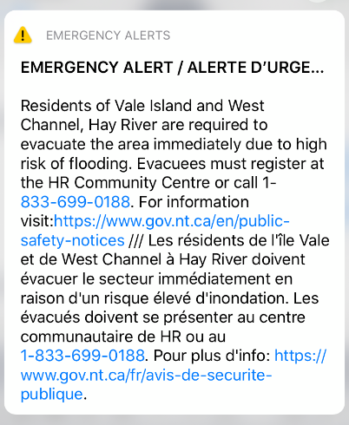

Benefits of NWT Alert
Communities are responsible for keeping their residents informed during emergencies. Clear communications by appropriate authorities are critical before, during and after an emergency in order to:
- Prepare residents
- Ensure public safety
- Protect property
- Facilitate response efforts
- Instill public confidence
Emergency communications may include:
- Alerts and warnings
- Evacuation instructions
- Road and/or facility closures
- Self-protective actions
Communities can alert residents in the following ways:
- Community government websites
- Community government social media
- Local radio stations
- Local notices/message boards
- Door-to-door notification.
- NWT Alert

Getting started NWT Alert
To request the use of NWT Alert in your community please reach out to your MACA Regional Superintendent:
- North Slave Regional Office: Justin Hazenberg, (867) 767-9161 ext. 21130, Justin_Hazenberg@gov.nt.ca
- South Slave Regional Office: Mary Blake-Moore, (867) 872-6531, Mary_Blake-Moore@gov.nt.ca
- Sahtu Regional Office: Christina Gaudet, Christina_Gaudet@gov.nt.ca, (867) 587-7105
- Dehcho Regional Office: Mike Drake, (867) 695-7220, Christina_Gaudet@gov.nt.ca
- Inuvik Regional Office: Dana Moran, (867) 777-7120 / Cell: (867) 678-0007, Dana_Moran@gov.nt.ca
- Manager, Community Engagement-MACA EMO: Dawn Ostrem, (867) 767-9161 ext. 21043, Dawn_ostrem@gov.nt.ca

