#BeReadyNWT: Risk and Emergency Preparation Messages for Social Media and Community Radio

Government of the Northwest Territories

Last Updated: March 2022

Contents
What the guide is for? 5
Who the guide is for? 5
What’s in the guide 6
Social media messages 6
Community radio scripts 6
How to use the guide 6
Check out the new website 6
Decide on how you want to communicate 7
Determine what the most important things are for your community 7
Turn to the relevant section 7
Customize for your community 7
Pick the right image for social media 7
Use as needed 8
Using messages for other communications products 8
Sharing information on your website 8
Tips for making the messages hit home 8
Why radio and social media? 9
Updates 9
Questions? 9
Messaging for Facebook 10
Emergency plans and kits 10
Suggested graphics 10
Post text 11
For those with special needs/elderly/disabilities 13
Suggested graphic 13
Post text 13
For pets 14
Suggested graphic 14
Post text 15
Floods 16
Before a flood 16
Suggested graphics 16
Post text 16
During a flood 19
After a flood 21
Suggested graphic 21
Post text 21
Evacuations 22
Suggested graphic 22
Post text 23
General 23
Ahead of spring break-up 23
Suggested graphic 24
Post text 24
During wildfire season 24
Suggested graphic 24
Post text 25
NWT Alert 25
Suggested graphic 25
Post text 26
Communicating during disasters 27
Suggested graphic 27
Post text 27
Tailored for use by community governments 27
Suggested graphic 28
Post text 28
Messaging for Twitter 29
Emergency plans and kits 29
Suggested graphics 29
Post text 30
For those with special needs/elderly/disabilities. 32
Suggested graphic 32
Post text 32
For pets 33
Suggested graphic 33
Post text 33
Flooding 34
Suggested graphics 34
Before a flood 35
During a flood 38
After a flood 39
Evacuations 40
Suggested graphics 40
Post text 40
NWT Alert 41
Suggested graphic 41
Post text 41
Community radio scripts 42
For emergency preparation – general 42
Script 1 – Four Steps to Be Ready for Any Emergency 42
Script 2 – Make an emergency plan 43
Script 3 – Build an emergency kit 44
Script 4 – Understanding the community emergency plan 45
For floods - general 47
Script 1 – Get Ready for Possible Floods 47
Script 2 – How to protect your property from a flood 48
For floods – risk rising in your area 49
Script 1 – Get Ready for Flooding Now 49

What the guide is for?
In the Northwest Territories, we face many risks for emergencies across our communities.
Avoiding damage and staying safe comes down to more than actions by experts and governments – it comes down to personal preparedness and understanding the risks before emergencies happen.
That means communicating early, often, and where the emergencies and audiences are.
This guide provides general options for messaging about emergency preparedness – ahead of hazards, and when those hazards become imminent.
It is intended to provide a resource for consideration by local emergency authorities with messages that can be customized to fit their needs.

Who the guide is for?
This guide can assist stakeholders in emergency preparedness and management in reaching audiences with common messages about emergency preparation.
That includes:
- Territorial government
- Local governments
- Indigenous governments
- Indigenous organizations
- Local organizations
- Partner agencies (i.e. Fire Departments, RCMP, Health Authorities)
- Non-profit organizations (i.e. NWT Association of Communities, Local Government Administrators of the NWT)

What’s in the guide

Social media messages
As the most common social media networks used by agencies and governments, content is tailored to Facebook and Twitter. Separate sections are maintained in this guide for posts geared towards each platform.
These are general messages which can be:
- Used directly by partner organizations, agencies, or residents
- Customized to fit specific scenarios
Messages prepared for Twitter may also be used on Facebook if you wish.
Messages prepared for Facebook are likely too long for Twitter, which allows a maximum of 280 letters, symbols, or spaces in each post.
While these messages were composed for Facebook and Twitter, they can be used on Instagram or other social media platforms your organization may use.

Community radio scripts
These scripts are intended for use on local community radio.
Prompts are provided in square brackets to customize content to fit your community’s needs.
The GNWT has already provided these scripts for public information announcements at appropriate times to the following major media organizations:
- CKLB Radio
- Radio Taiga
- CBC North
- TrueNorthFM
- Cabin Radio

How to use the guide
Here is how you can best use this guide to help your organization communicate about emergency preparedness.

Check out the new website
We have made a lot of changes to emergency preparation material on our website. It is a good idea to have a look and familiarize yourself with it. This will allow you to understand what is available to folks in your community.

Decide on how you want to communicate
Do you have a website? A page on social media? A newsletter?
Do the folks you serve use Facebook community groups – like those for buying and selling or posting community events?
These are all great ways to communicate with people.
Decide which way you want to communicate with your residents before you choose messages.

Determine what the most important things are for your community
Every community’s residents need to be ready for emergencies – and general preparation like emergency planning and building emergency kits is always relevant.
But are there specific risks they should be thinking about?
For example, many communities are at higher risks of flooding than others. Pick the risks most relevant to your community, and decide on the right times to post about them during the year.
Use your emergency plan to help!

Turn to the relevant section
There are sections with messages tailored especially for specific platforms
If you are communicating on Facebook, turn to the Facebook section of this guide.
If you are communicating on Twitter, turn to the Twitter section of this guide.
If you are communicating on community radio, turn to the community radio section of this guide.
The messages in these sections are written to work with the given platform. Choose which one works best for what you want to communicate.

Customize for your community
Certain messages include placeholders needing your organization’s input. Suggestions of what would be useful to include are provided in some of these placeholders.
But also, if there is additional information you believe should be included, or could make the message work better with people who live in your community, go ahead and customize it!

Pick the right image for social media
No matter what platform you’re using, social media posts with high-quality images or graphics are proven to grab and keep people’s attention.
Basic graphic and image suggestions are included in this guide based on key themes. Feel free to use these graphics and images – or to choose images you feel are more relevant to your community.
It’s up to you!
To download the graphics :
- Right click on the image
- Select “Save as Picture”
- Save it to the appropriate folder on your computer
Note: they may appear small, but will save full-size if you use this method!

Use as needed
These messages can be used any time to help folks in your community be ready for any emergency!

Using messages for other communications products
You may wish to use messaging in this guide in other forms of communication like emails, posters, community radio, newsletters.
You are encouraged to do so! You know your community best – help reach everyone with most effective methods for your community.

Sharing information on your website
Your organization may have emergency messaging available publicly on your website or through other means.
The content of this guide may be used to improve or enhance emergency messaging.
It is advisable to update relevant information as soon as possible when updates to this guide are provided.

Tips for making the messages hit home.
- Start early: It’s never too early to start telling your residents how to prepare for emergencies. The best time to think about emergency planning and preparation is when there is no emergency!
- Make emergency preparation an event: Consider making community events focused on emergency preparation – like a “Safety Corner” on your local community radio channel. You can use these messages to help you get started!
- Use community Facebook groups: Community Facebook groups are important places where residents gather online. This makes them great places to share information, but also places where misinformation can spread fast. Having a strong, consistent, official presence from your organization can help residents get timely and accurate information and reduce the potential for misinformation and rumours.
- Use your community’s airport code as a hashtag: Using hashtags can give people one place to go on social media to find information about their community. Most communities use their airport codes. Here are some examples:
  - For posts about Yellowknife: Use #yzf
  - For posts about Inuvik: Use #yev

Why radio and social media?
- Feedback received from residents, Indigenous governments, Indigenous organizations, and community governments indicate that many are increasingly getting information from social media.
- Community radio is also regularly cited as one of the most important resources for residents – especially in smaller communities.
- With that in mind, the GNWT has chosen to focus this guide on these two important mediums.

Updates
This guide may be updated from time-to-time. The GNWT’s Department of Municipal and Community Affairs will make updates available to governments and agencies as they are completed.

Questions?
If you have any questions about this guide, contact your regional Municipal and Community Affairs office.

Messaging for Facebook

Emergency plans and kits
Tip: Emergency plans and kits are relevant to any hazard. Customize general posts to fit with any specific hazard that could be coming.
For example:
Wildfire season runs May 1 – September 30 and every community below the tree line is at-risk. Mention wildfire season in posts scheduled during this time.
Risk of flooding is highest at spring break-up. Mention spring break up in the months of February-June to make it more real.

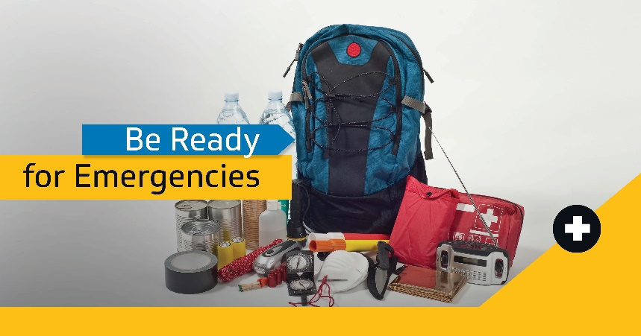
Suggested graphics

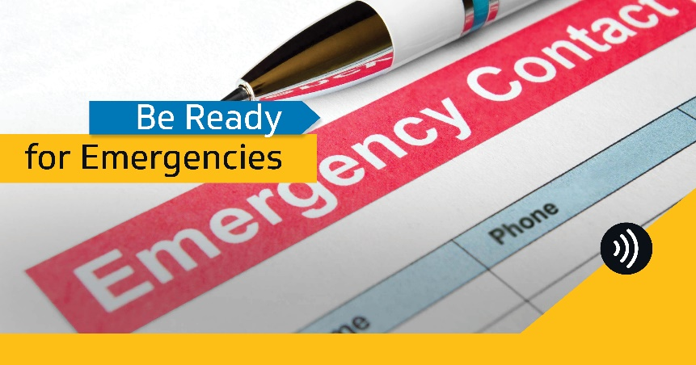

Post text
Making an emergency plan for your home requires understanding the hazards relevant to your community and how your community’s emergency plan works.
Look on your community’s website, email, or call your community government to learn about their emergency plan before you build yours.
For more information on preparing your own emergency plan, check out the link. https://www.maca.gov.nt.ca/en/services/be-ready-emergencies/be-ready-make-emergency-plan-and-kit
While COVID is a concern today, can you name the top 5 hazards in your community or region during a normal year? Different hazards can happen in each area of the territory, but all of them require having a plan and getting prepared. The territory’s top five are:
✔️Floods
✔️Wildfires
✔️Severe weather
✔️Transportation incidents (car accidents, road washouts)
✔️Critical infrastructure failure (like power outages)
Be ready for any emergency: check out the link for tips to prepare for any hazard. https://www.maca.gov.nt.ca/en/services/be-ready-emergencies/be-ready-make-emergency-plan-and-kit

There are many hazards you can face in the NWT. The good news: you can be ready for any emergency with these simple steps.
📋Make an emergency plan
✔️Create a checklist for your emergency kit
🧳 Gather your supplies
🧑🏽‍🤝‍🧑🏽Test your plan with your household every year
Build your emergency plan online, get checklists, and learn lots of tips to be ready when emergencies strike at the link. https://www.maca.gov.nt.ca/en/services/be-ready-emergencies/be-ready-make-emergency-plan-and-kit

An emergency plan isn’t just a contact list. Be ready with an emergency plan that includes the needs of everyone in your life, from children and pets to folks with special needs or disabilities, Get checklists and tips at the link. https://www.maca.gov.nt.ca/en/services/be-ready-emergencies/be-ready-make-emergency-plan-and-kit
After an emergency, you may need to stay at home with no power or running water. Gather supplies that will support your household for a minimum of 3 to 7 days and store them in an easy-to-access place. Some things to include:
✔️Water and non-perishable food
✔️Battery-powered or hand crank radio & flashlight
✔️First aid kit
✔️Copy of your emergency plan
Build your emergency plan and kit with tips and checklists online to be ready for any emergency. https://www.maca.gov.nt.ca/en/services/be-ready-emergencies/be-ready-make-emergency-plan-and-kit
Building an emergency kit doesn’t have to break the bank. You probably already have a lot of what you need at home. Here are a few things to check for.
✔️Warm clothes and shoes – save a few items from your donation pile!
✔️Toiletries – travel size bottles work great!
✔️Water – use some of those leftover 2 litre bottles!
Be ready before emergency strikes: get tips and checklists to help build your emergency kit at the link. https://www.maca.gov.nt.ca/en/services/be-ready-emergencies/be-ready-make-emergency-plan-and-kit
Family members aren’t the only people you may need to get in touch with during an emergency. You will also want contact information for:
✔️ Your children’s schools
✔️ Emergency contacts outside the city
✔️ Your neighbours
✔️ Your landlord
✔️ Your utility companies
Make an emergency plan to be ready for any emergency. Learn how at the link. https://www.maca.gov.nt.ca/en/services/be-ready-emergencies/be-ready-make-emergency-plan-and-kit

Planning for emergencies can be quick and easy with this fill-in-the-blanks emergency plan.
Download or print it – you’ll be done before you know it. Be ready with a plan so you can focus on the important things when emergencies come. Visit the link for more. https://www.maca.gov.nt.ca/en/services/be-ready-emergencies/be-ready-make-emergency-plan-and-kit
Be ready to shelter at home with no power or running water during emergencies. Learn how to build an emergency kit so you’ll be ready to “camp at home” safely. You probably already have a few things to get started!
Get tips on building your kit at the link. https://www.maca.gov.nt.ca/en/services/be-ready-emergencies/be-ready-make-emergency-plan-and-kit

For those with special needs/elderly/disabilities

Suggested graphic
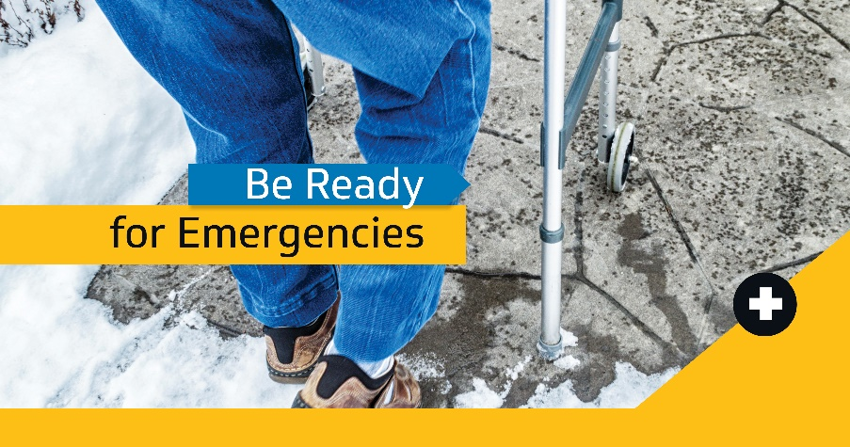

Post text
If you have elderly friends, family, or neighbours, ask if they have an emergency plan or would like help making one. Those with mobility issues or medical needs will especially benefit from a plan and support network that can help during an emergency.
Use online checklists and tips at the link to help. https://www.maca.gov.nt.ca/en/services/be-ready-emergencies/be-ready-make-emergency-plan-and-kitIf you have a disability or medical needs, make sure to have a bag ready in case you need to leave on short notice. It should include critical medications or special equipment. Other things to consider as part of your planning:
✔️ Communication challenges you may encounter
✔️ Unfamiliar or hard-to-navigate environments
✔️ Your service animal’s needs
Get more tips on being ready at the link. https://www.maca.gov.nt.ca/en/services/be-ready-emergencies/be-ready-make-emergency-plan-and-kit

______________________________________________________________________________

If you or someone close to you has a disability or mobility issue, having a support network can help with acting quickly and safely during an emergency. A support network can include friends, family, caregivers, and neighbours. When building your support network also consider:
✔️ Giving trusted people access to your home so they can check on you
✔️ Showing them where your emergency plan & supplies are
✔️ Agreeing to notify each other when you’re going out of town
Get more tips on preparing for emergencies at the link. https://www.maca.gov.nt.ca/en/services/be-ready-emergencies/be-ready-make-emergency-plan-and-kit

For pets

Suggested graphic
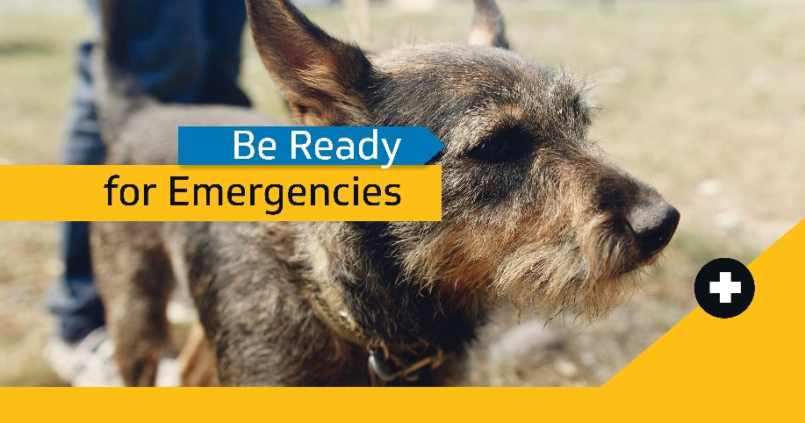

Post text
Don’t forget to plan for your pet before emergencies come! If you must leave home on short notice, make sure you have a grab-and-go bag packed for your pet including:
✔️ Food, water and treats
✔️ Leash or harness
✔️ Extra medications and comfort items
✔️ ID, vaccination & medical info
Get more tips to be ready for emergencies at the link. https://www.maca.gov.nt.ca/en/BeReadyNWT

Emergencies are extra stressful for pets. Being prepared means being ready to help them too. Plan ahead – and consider thoughtful touches like these in your emergency kit with the essentials:
👚 A shirt that smells like you: your scent can help keep them calm
🧸 Favourite toys: to keep them busy
😻 Treats: to reward them for being good under the stress
There are many more ways you can be ready before emergencies strike. Check out this website for more. https://www.maca.gov.nt.ca/en/BeReadyNWT

Floods

Before a flood

Suggested graphics
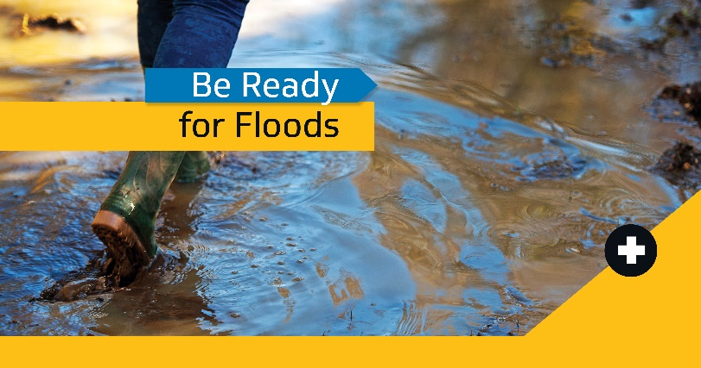
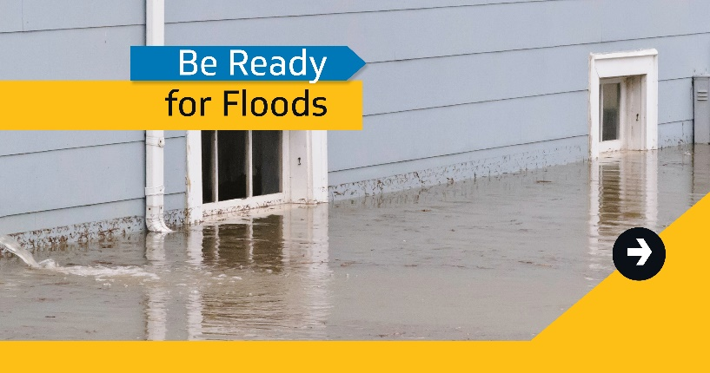

Post text

Leading up to spring break-up
The first step to getting prepared is learning what hazards could occur where you live. If you’re at risk for a #NWTFlood, make a plan and build an emergency kit before waters start to rise. Learn more at: https://www.maca.gov.nt.ca/en/services/be-ready-emergencies/be-ready-make-emergency-plan-and-kit
As spring break-up gets closer and NWT flood risk increases, get ready by making emergency kits for each member of your family. Be sure to pack everything you’ll need if you must evacuate. Learn more about preparing for floods: https://www.maca.gov.nt.ca/en/services/be-ready-emergencies/flood
______________________________________________________________________________
Floods are a major hazard in the #NWT. They usually happen during spring break-up due to ice jams or high water – and some communities are at more risk than others. Learn about floods and how to protect your property: https://www.maca.gov.nt.ca/en/services/be-ready-emergencies/be-ready-floods #nwtpoli #BeReadyNWT
Any community near NWT rivers are at-risk of floods during break-up, but some are at higher risk than others. Those communities are:
⚠️Hay River ⚠️Kátł’odeeche
⚠️ Jean Marie River
⚠️Fort Liard ⚠️ Fort Simpson
⚠️Aklavik ⚠️ Fort Good Hope
⚠️Tulita ⚠️ Nahanni Butte
If you’re in these communities, don’t wait to prepare. There are many ways to reduce potential flood damage and risk to your family. Check out the link for tips to be ready before the water comes. https://www.maca.gov.nt.ca/en/services/be-ready-emergencies/be-ready-floods
Floods can happen anywhere near rivers during spring break-up – no matter the water level. Ice jamming up in river channels is usually the cause.
Here are steps everyone should take to be ready for floods:
✔️ Keep valuables safe: Store valuables and important items or documents in water-tight containers or in higher places, like on a tall shelf or upper floor
✔️ Keep gutters clear
✔️ Keep foundations clear of snow: Clear snow at least 1 to 1.5 metres away from your home's foundation
✔️ Secure your fuel tank: Make sure to anchor any heating oil or propane tanks to the floor or ground. Call your fuel provider for advice. If you rent, talk to your landlord to ensure this is done.
✔ Secure your water and sewage holding tanks
Get many more tips on protecting your property from flood damage at the link. https://www.maca.gov.nt.ca/en/services/be-ready-emergencies/be-ready-floods

Flood season is coming soon. Do you know your financial risk? Here are three things to know:
✔️Many insurance plans don’t cover floods: don’t assume yours does
✔️Your insurance provider may be able to help: call them and discuss what would be covered in a flood and look at options
✔️Government assistance won’t cover all losses: it’s only made available in widespread disasters and won’t cover all your costs.
Learn more about financial risk and how to protect your property at the link. https://www.maca.gov.nt.ca/en/services/be-ready-emergencies/be-ready-floods
In a flood risk community? Be ready before the ice breaks up and flood risk increases: take these extra steps to protect your property from damage whenever you can:

✔️ Seal key structures: Apply weather protection sealant around basement windows and the base of ground-level doors
✔️ Keep important equipment off the ground: Use wood or cement to raise appliances above flood level
✔️Move vehicles and equipment to safe areas
Even more tips for protecting your property at the link. https://www.maca.gov.nt.ca/en/services/be-ready-emergencies/flood

Late-spring/summer/early-fall
In a flood risk community? Be ready for risks ahead of time: take these extra steps this season to protect your property from damage whenever you can:
✔️Flood resistant landscaping: Make sure water drains away from your foundation. Dig trenches for water to fill before it reaches your home.
✔️ Install flood barriers: Consider permanent self-closing flood barriers to keep water out of your home for as long as possible.
✔️ Build or renovate with flood safety in-mind: Use flood-resistant building material.
By taking steps now, you can be ready before the water comes. Visit the link for more tips and checklists. https://www.maca.gov.nt.ca/en/services/be-ready-emergencies/flood

During a flood
During a flood, the most important things to do are:
✔️ Listen to local authorities
✔️ Have your emergency kit nearby
✔️ Monitor radio and local news
✔️ Stay calm
Flooding is scary, but if everyone works together, we can stay as safe as possible.
If you are facing a flood in the NWT, monitor community message boards, local radio stations, television news and social media for the latest information from your local authorities. For reliable sources and links, visit: https://www.maca.gov.nt.ca/en/services/be-ready-emergencies/be-ready-stay-date-public-safety-information

Did you know: Just 6 inches of rushing water can knock an adult off their feet. Two feet of water can carry away most vehicles – including trucks and SUVs. NEVER attempt to drive, swim or walk across flooded areas. Learn more: https://www.maca.gov.nt.ca/en/services/be-ready-emergencies/during-flood #NWTFlood #nwtpoli #BeReadyNWT
_____________________________________________________________________________________
NWT flood tip: Do NOT attempt to shut off electricity if water is present. More here: https://www.maca.gov.nt.ca/en/services/be-ready-emergencies/during-flood #nwtpoli #BeReadyNWT

NWT flood tip: Raise electrical appliances off the ground if there is time. Always prioritize your safety. More here: https://www.maca.gov.nt.ca/en/services/be-ready-emergencies/during-flood #nwtpoli #BeReadyNWT [INSERT HASHTAGS OF AFFECTED COMMUNITIES]

NWT flood tip: Keep your phone battery as full as possible. Conserve battery life by dimming your screen and avoiding power-hungry apps and video. Find more tips: https://www.maca.gov.nt.ca/en/services/be-ready-emergencies/during-flood #nwtpoli #BeReadyNWT [INSERT HASHTAGS OF AFFECTED COMMUNITIES]

Under evacuation alert for a #NWTFlood?

✔️ LISTEN TO COMMUNITY GOV’T
✔️ Have emergency kits packed
✔️ Park vehicles away from waterways
✔️ Raise appliances off the ground
✔️ Move valuables to upper floors/areas
✔️ Anchor fuel tanks, water and sewage holding tanks
#nwtpoli #BeReadyNWT

Know the difference between an evacuation alert & order if you’re at risk for a #NWTflood.
⚠️ Alert: You’re at-risk of evacuation. Get emergency supplies and be ready to leave
🚨 Order: You are in danger. Leave now.
#nwtpoli #BeReadyNWT
https://www.maca.gov.nt.ca/en/services/be-ready-emergencies/be-ready-understand-and-plan-evacuations

After a flood

Suggested graphic
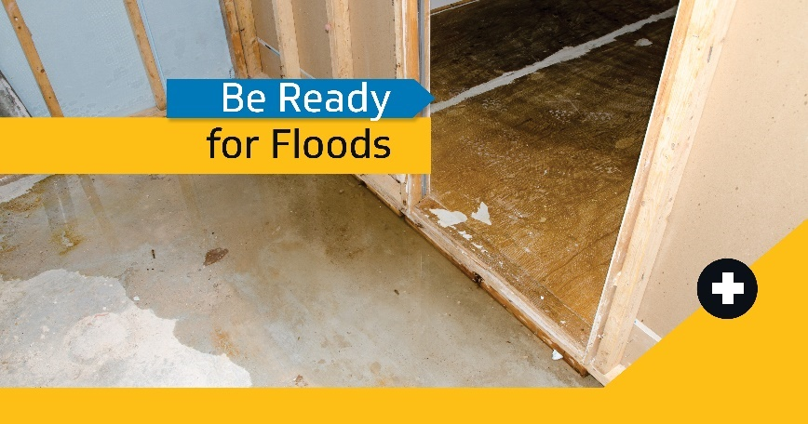

Post text
Cleaning up after a flood? Get tips online to help you create a clean up plan to help return your home to normal. https://www.maca.gov.nt.ca/en/services/be-ready-emergencies/after-flood

Following a flood you may see or smell mould. Mould grows in wet and damp conditions, but it's less likely to grow if you can dry out your home and household items within 48 hours. For more flood clean up tips, check out this link: https://www.maca.gov.nt.ca/en/services/be-ready-emergencies/after-flood
Following a #NWTFlood, your community may continue to offer supports like reception centres. Check with your local government office to learn about the services they may offer.
Tip: edit this post to include details like the location of places where people can get help.
Cleaning up after a flood can pose health risks. You may see or smell mould on clothing, drywall, furniture, cardboard boxes or books, but it may also be hidden under or behind items like carpet, cushions or walls. More tips at the link. https://www.maca.gov.nt.ca/en/services/be-ready-emergencies/after-flood

Heading home after a flood? Remember it’s not safe until authorities say so and your home has been cleared of any structural, electrical or other hazards. More tips at the link. https://www.maca.gov.nt.ca/en/services/be-ready-emergencies/after-flood
Before you start cleaning up after a #NWTFlood, call your insurance company. Make a list of all damaged items. Take photos and keep related receipts. Learn more: https://www.maca.gov.nt.ca/en/services/be-ready-emergencies/after-flood

Evacuations
Tip: evacuations may happen during any emergency. Customize general posts any time there are specific hazards that could be coming.
For example:
Wildfire season runs May 1 – September 30 and every community below the tree line is at-risk. Mention wildfire season in posts scheduled during this time.
Risk of flooding is highest at spring break-up. Mention spring break up in the months of February-June to make it more real.

Suggested graphic
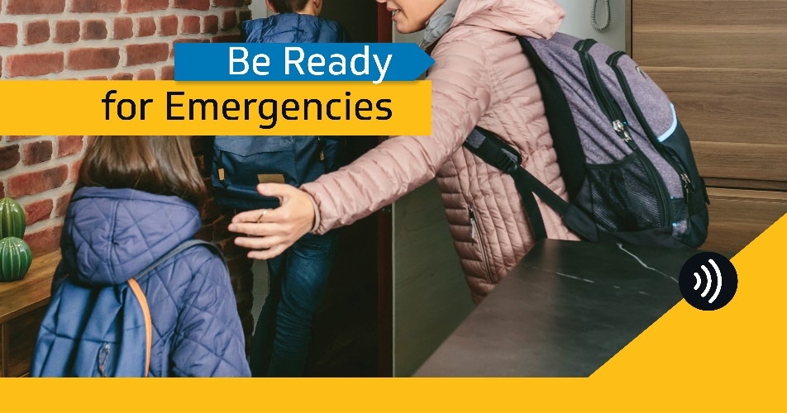

Post text

General
Evacuations are difficult, but sometimes necessary. The most important things you need to do to be ready to leave during an emergency are:
✔️Stay up to date: listen to radio, read local news, follow community and territorial government alerts online
✔️Make your emergency plan
✔️Make your emergency kit
Understand how evacuations work and get more tips to be ready when they happen at the link. https://www.maca.gov.nt.ca/en/services/be-ready-emergencies/be-ready-understand-and-plan-evacuations
Sometimes, you may need to leave home during an emergency. Know the difference between evacuation notices, alerts and orders.
Evacuation Notice: to advise you that an emergency event, such as a wildfire or flood, may present an increased risk to your community and could endanger life or property.
⚠️Evacuation Alert: You are at risk. Get ready to leave on short notice.
🚨Evacuation order: You are in danger. Leave now – bring your emergency kit, follow directions from officials.
✔️All-clear: The emergency is over. Go home if it’s safe. Stay aware – danger may return.
Understand and plan for evacuations. Get tips at the link. https://www.maca.gov.nt.ca/en/services/be-ready-emergencies/be-ready-understand-and-plan-evacuations

Ahead of spring break-up

Suggested graphic
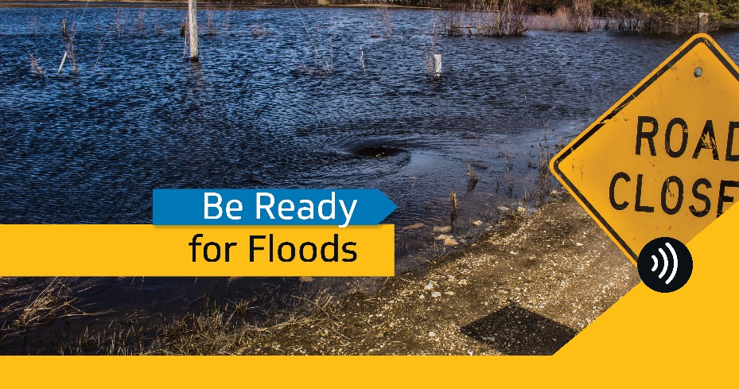

Post text
Spring break-up is coming, and there is always a risk of floods. Know the evacuation advisories and what they mean.

Evacuation Notice: to advise you that an emergency event, such as a wildfire or flood, may present an increased risk to your community and could endanger life or property.
⚠️Evacuation Alert: You may be at risk. Get ready to leave on short notice.
🚨Evacuation order: You are in danger. Leave now – follow all directions from officials.
✔️All-clear: The emergency is over. Go home when officials determine it’s safe. Stay aware – danger may return.
Understand and plan for evacuations. Get tips at the link. https://www.maca.gov.nt.ca/en/services/be-ready-emergencies/be-ready-understand-and-plan-evacuations

During wildfire season

Suggested graphic
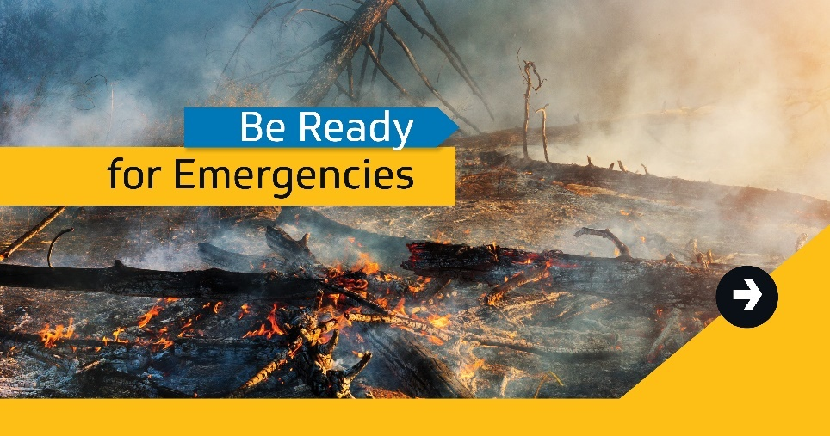

Post text
Wildfire season is here. Many NWT communities have been evacuated due to wildfires in the past. Understand the difference between evacuation notices, alerts and orders so you know when to go:

Evacuation Notice: to advise you that an emergency event, such as a wildfire or flood, may present an increased risk to your community and could endanger life or property.
⚠️Evacuation Alert: You may be at risk. Get ready to leave on short notice.
🚨Evacuation order: You are in danger. Leave now – follow all directions from officials.
✔️All-clear: The emergency is over. Go home if it’s safe. Stay aware – danger may return.
Understand and plan for evacuations. Get tips at the link. https://www.maca.gov.nt.ca/en/services/be-ready-emergencies/be-ready-understand-and-plan-evacuations

NWT Alert

Suggested graphic
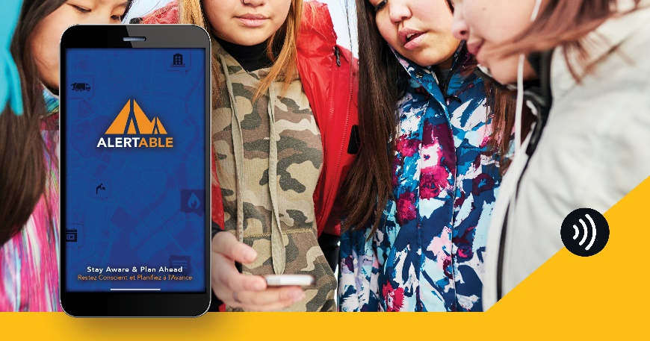

Post text
Many may have received NWT Alert test messages on cellphones, TV, or radio in the last year. But there’s also a website and app providing notices of most public safety advisories in the NWT – like weather, 9-1-1 outages, road closures, etc.
Check out the website: NWT Alert
Download for Android: https://play.google.com/store/apps/details?id=com.artermobilize.alertable&hl=en_CA&gl=US
Download for iPhone: https://apps.apple.com/ca/app/alertable/id1277488940
Stay up-to-date on any emergency with our guide to reliable public safety information sources: https://www.maca.gov.nt.ca/en/services/be-ready-emergencies/be-ready-stay-date-public-safety-information
______________________________________________________________________________

Did you know: Communities are able to request alerts for evacuations and other emergency response direction through NWT Alert? In big emergencies, they can choose to send alerts for evacuations to all radios, TVs, and cell phones in the area.
Visit the NWT Alert website to get most public safety and emergency advisories in the NWT.
Download the Alertable app from the App Store or Google Play to get advisories to your phone any time. https://nwtalert.ca/#/

Communicating during disasters

Suggested graphic
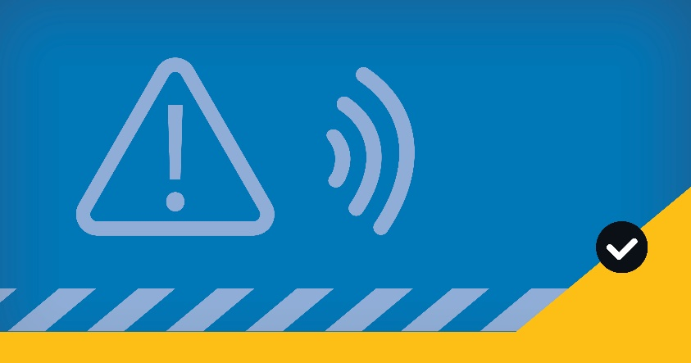

Post text
When disaster strikes, how will you and your family stay in touch if phone lines are jammed or down?
Try making a private social media group and practice checking in. You never know when you’ll need it!
More tips on being ready for emergencies at the link. https://www.maca.gov.nt.ca/en/BeReadyNWT
______________________________________________________________________________
During an emergency, getting trusted information from your community government is so important. Find out where they will share alerts and updates before disaster strikes and add them to your plan and cell phone.
✔️ TV or radio
✔️ Official website
✔️ Social media accounts and groups
Learn more with our guide to finding reliable information about public safety and emergencies. https://www.maca.gov.nt.ca/en/services/be-ready-emergencies/be-ready-stay-date-public-safety-information

Tailored for use by community governments

Suggested graphic
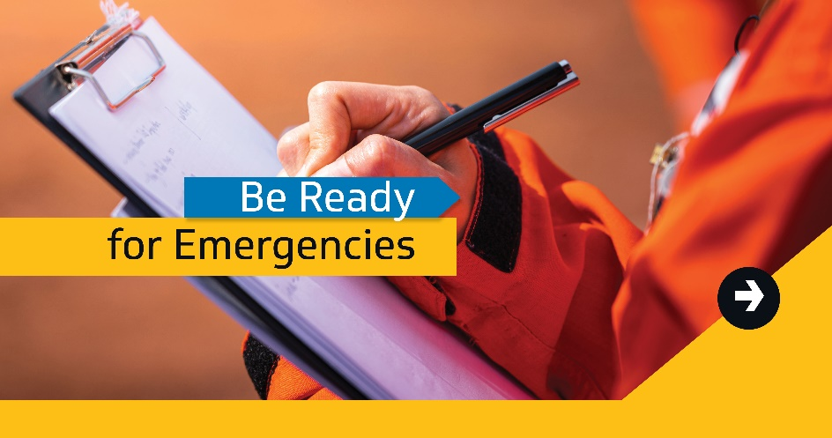

Post text
Have you made an emergency plan yet? When you do, remember to write down the best sources for information.

✔️ [LIST ANYWHERE THE COMMUNITY GOVERNMENT PLANS TO PROVIDE INFORMATION]
✔️ [INCLUDE SOCIAL MEDIA ACCOUNTS]
✔️ [OFFICIAL WEBSITE]
✔️ [COMMUNITY RADIO IF APPLICABLE]
Learn more about planning and preparing for emergencies at the link. https://www.maca.gov.nt.ca/en/BeReadyNWT
Emergencies can happen any time. All [INSERT COMMUNITY NAME] residents need to be prepared. The biggest hazards we face are:
[INSERT HAZARDS]
Make your emergency plan and kit online with checklists. https://www.maca.gov.nt.ca/en/services/be-ready-emergencies/be-ready-make-emergency-plan-and-kit
Did you know: If you ever need to evacuate in [INSERT COMMUNITY NAME], this is where you would likely go:
[INSERT LOCATION OF EVACUATION ASSEMBLY POINT]
Bring your emergency kits, get registered with local emergency officials, and they’ll provide you the best advice to stay safe.
Get more tips on preparing for emergencies at the link. https://www.maca.gov.nt.ca/en/BeReadyNWT
Floods are a real risk to us in [INSERT COMMUNITY NAME] – and risk is highest at break-up. They’re usually caused by ice jams and can happen at any time of day or water level. So be ready before the water comes: https://www.maca.gov.nt.ca/en/services/be-ready-emergencies/flood

Messaging for Twitter

Emergency plans and kits

Suggested graphics
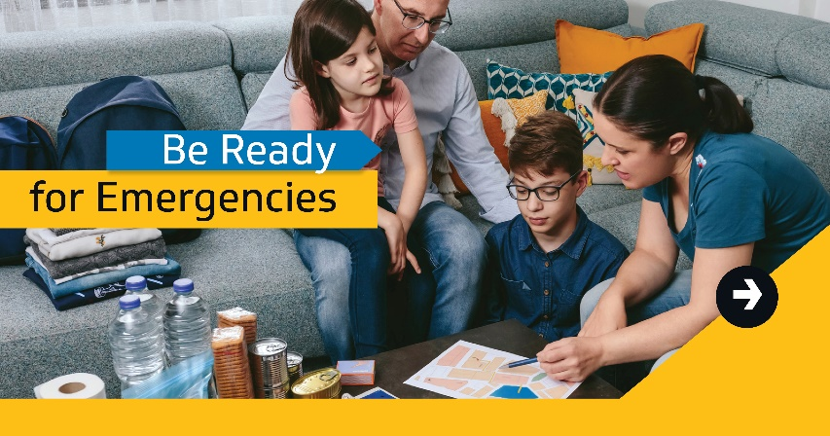
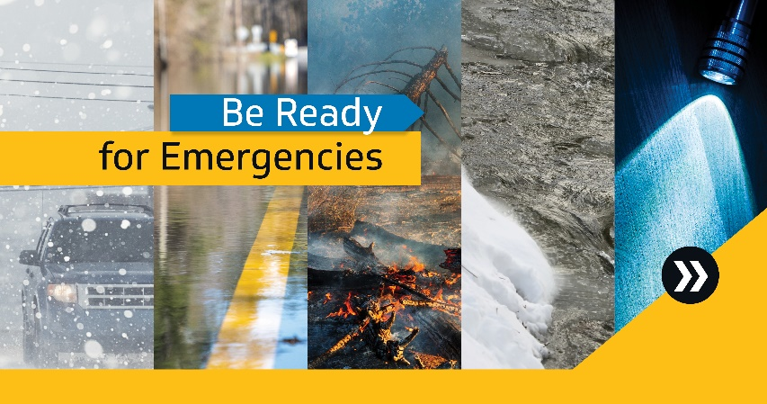

Post text
Tip: evacuations CAN HAPPEN DURING ANY EMERGENCY. Customize general posts to fit with any time there are specific risks that could be coming.
For example: Wildfire season runs May 1 – September 30 and every community below the tree line is at-risk. Mention wildfire season in posts scheduled during this time.
Risk of flooding is highest at spring break-up. Mention spring break up in the months of February-JUNE to make it more real.
Making an emergency plan for your home requires an understanding of hazards for your community and region and an understanding of how your community’s emergency plan works.
Look on your community’s website, email, or call your community government to learn about the community emergency plan before you build yours.
Tips on building your emergency kit: https://www.maca.gov.nt.ca/en/services/be-ready-emergencies/be-ready-make-emergency-plan-and-kit
Top 5 hazards in the #NWT (when #COVID isn’t happening):
✔️Floods
✔️Wildfires
✔️Severe weather
✔️Transportation incidents (car accidents, road washouts)
✔️Critical infrastructure failure (like power outages)
#BeReadyNWT: make your emergency plan and kit today. Tips: https://www.maca.gov.nt.ca/en/services/be-ready-emergencies/be-ready-make-emergency-plan-and-kit #nwtpoli #yzf
______________________________________________________________________________
There are many hazards in the #NWT. #BeReady for any emergency:
📋Make an emergency plan
✔️Make a checklist for your emergency kit
🧳 Gather your supplies
🧑🏽‍🤝‍🧑🏽Test your plan with your household every year
Tips: https://www.maca.gov.nt.ca/en/services/be-ready-emergencies/be-ready-make-emergency-plan-and-kit #nwtpoli #yzf

An emergency plan isn’t just a contact list. #BeReadyNWT: make an emergency plan that includes the needs of everyone in your life, from children and pets to folks with special needs or disabilities, and more! Checklists and tips: https://www.maca.gov.nt.ca/en/services/be-ready-emergencies/be-ready-make-emergency-plan-and-kit #nwtpoli #yzf
#BeReadyNWT: Gather supplies to last at least 3 to 7 days after an emergency:
✔️Water and non-perishable food
✔️Battery-powered or hand crank radio & flashlight
✔️First aid kit
✔️Copy of your emergency plan
Tips and checklists for emergency plans and kits: https://www.maca.gov.nt.ca/en/services/be-ready-emergencies/be-ready-make-emergency-plan-and-kit #nwtpoli #yzf
Being ready for emergencies doesn’t need to break the bank. You probably have a lot at home already:
✔️Warm clothes and shoes
✔️Toiletries – travel size bottles work great!
✔️Water – use leftover 2 litre bottles!
Build your emergency plan and kit with these tips: https://www.maca.gov.nt.ca/en/services/be-ready-emergencies/be-ready-make-emergency-plan-and-kit #nwtpoli #BeReadyNWT

Family members aren’t the only people you may need to get in touch with during an emergency. Other important contacts:
✔️ Children’s schools
✔️ Neighbours
✔️ Landlord
✔️ Utility companies
Build your emergency plan and kit with tips here: https://www.maca.gov.nt.ca/en/services/be-ready-emergencies/be-ready-make-emergency-plan-and-kit #BeReadyNWT
Planning for emergencies is quick and easy with this fill-in-the-blanks emergency plan.
Download or print it – you’ll be done before you know it. It will help you focus on the important things when emergencies happen. More tips: https://www.maca.gov.nt.ca/en/services/be-ready-emergencies/be-ready-make-emergency-plan-and-kit #nwtpoli #BeReadyNWT #yzf
Be ready to shelter at home with no power or running water during emergencies. Learn how to build an emergency kit so you’ll be ready to “camp at home” safely. You probably already have a few things to get started!
Tips on building your kit: https://www.maca.gov.nt.ca/en/services/be-ready-emergencies/be-ready-make-emergency-plan-and-kit #nwtpoli #BeReadyNWT

For those with special needs/elderly/disabilities.

Suggested graphic
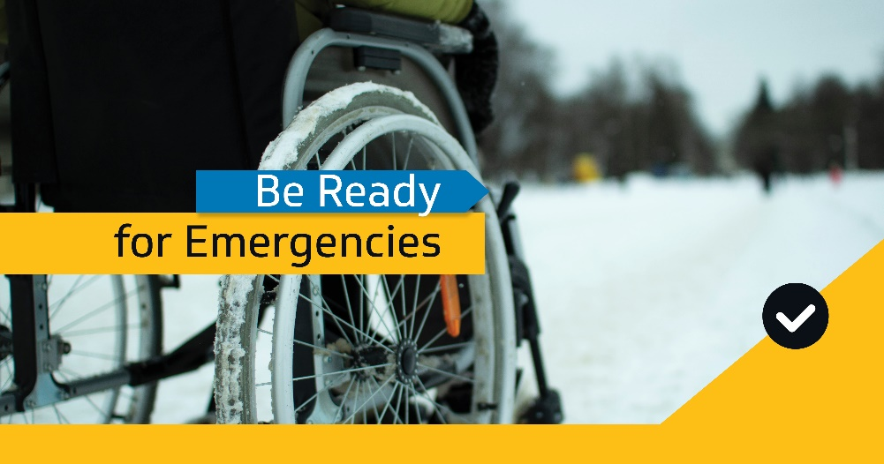

Post text
If you have elderly friends, family or neighbours, ask if they have an emergency plan or would like help making one. Those with mobility issues or medical needs will benefit from a plan and support network that can help during emergencies.
Online checklists and tips: https://www.maca.gov.nt.ca/en/services/be-ready-emergencies/be-ready-make-emergency-plan-and-kit #BeReadyNWT #nwtpoli #yzf

If you have a disability or medical needs, have a bag ready with medications or equipment for emergencies. Other things to consider:
✔️ Communication challenges you may encounter
✔️ Unfamiliar or hard-to-navigate environments
✔️ Your service animal’s needs
#BeReadyNWT #nwtpoli
_____________________________________________________________________________
If you or someone close to you has a disability or mobility issue, friends, family, caregivers and neighbours really help in emergencies. When building support network consider:
✔️ Giving trusted people access to your home so they can check on you
✔️ Showing them where your emergency plan & supplies are
✔️ Agreeing to notify each other when you’re going out of town
More tips on getting prepared: [INSERT LINK: EMERGENCY PLANS AND KITS] #nwtpoli #BeReadyNWT

For pets

Suggested graphic
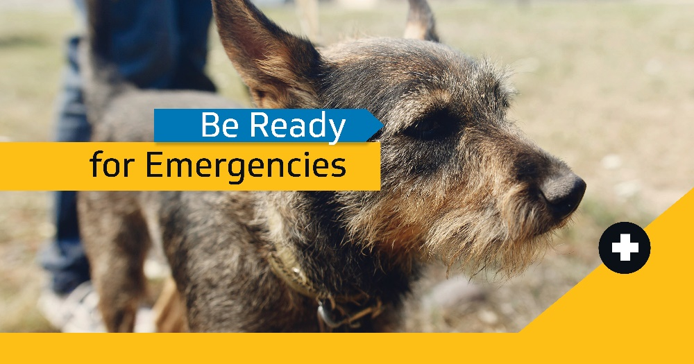

Post text
Don’t forget to plan for your pet before emergencies come! Make sure your emergency kit includes:
✔️ Food and water
✔️ Leash or harness
✔️ Extra medications and comfort items
✔️ ID, vaccination & medical info
More tips for preparing for emergencies: https://www.maca.gov.nt.ca/en/BeReadyNWT #nwtpoli #BeReadyNWT
__________________________________________________________
Emergencies are stressful for pets. Try thoughtful touches like these in your emergency kit alongside essentials:

👚 A shirt that smells like you: your scent can help keep them calm
🧸 Toys: to keep them busy
😻 Treats: to reward them for being good under the stress

#nwtpoli #BeReadyNWT

Flooding

Suggested graphics
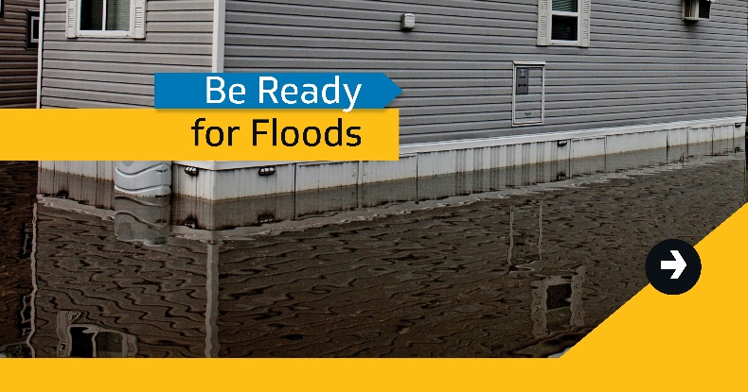
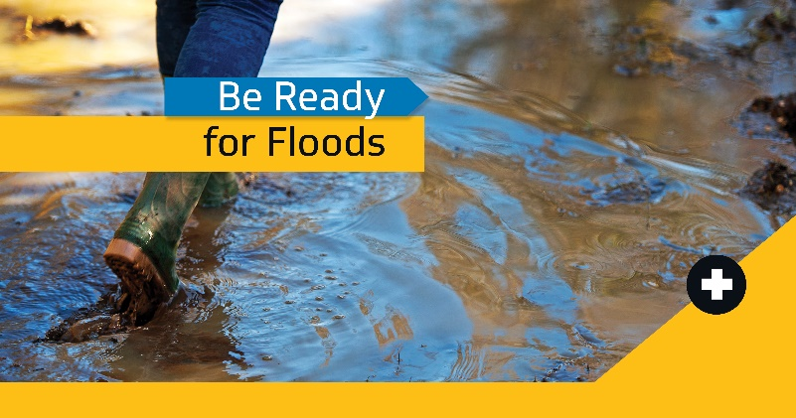

Before a flood
The first step to getting prepared is learning what hazards could occur where you live. If you’re at risk for a #NWTFlood, make a plan and build an emergency kit before waters start to rise. Learn more at: https://www.maca.gov.nt.ca/en/services/be-ready-emergencies/be-ready-make-emergency-plan-and-kit #nwtpoli #BeReadyNWT

Floods are a major hazard in the #NWT. They usually happen during spring break-up due to ice jams or high water – and some communities are at higher risk than others. Learn about floods and how to protect yourself and your property: https://www.maca.gov.nt.ca/en/services/be-ready-emergencies/be-ready-floods #nwtpoli #BeReadyNWT

Communities at higher #NWTFlood risk:
⚠️Hay River ⚠️Kátł’odeeche
⚠️ Jean Marie River
⚠️Fort Liard ⚠️ Fort Simpson
⚠️Aklavik ⚠️ Fort Good Hope
⚠️Tulita ⚠️ Nahanni Butte
Risk is highest at spring break-up. #BeReadyNWT: protect your property any time of year with these tips: https://www.maca.gov.nt.ca/en/services/be-ready-emergencies/be-ready-floods #nwtpoli

As spring break-up gets closer and #NWTFlood risk rises, get ready by making an emergency kit for each member of your family. Be sure to pack everything you’ll need if you must evacuate. Learn more about preparing for floods: https://www.maca.gov.nt.ca/en/services/be-ready-emergencies/flood

#NWTFlood tip: take time to prepare your home and family before spring break-up. Start by creating an emergency plan and building your emergency kit for everyone in your home (including pets!). Learn more at: https://www.maca.gov.nt.ca/en/services/be-ready-emergencies/be-ready-make-emergency-plan-and-kit #nwtpoli #BeReadyNWT

Don’t forget your pets when planning for a potential #NWTFlood. Start by adding their name, breed, vaccination history and a photo to your emergency plan. Learn about pet prep and more at: https://www.maca.gov.nt.ca/en/services/be-ready-emergencies/be-ready-make-emergency-plan-and-kit #nwtpoli #BeReadyNWT

Your pets will be counting on you during a #NWTFlood. Gather their things in your emergency kit so they’ll have everything they need if you must leave home in a hurry. Learn about pet preparedness and more: https://www.maca.gov.nt.ca/en/services/be-ready-emergencies/be-ready-make-emergency-plan-and-kit

How will you get info about a #NWTFlood in your area? Start by contacting your local government and find out where they’ll share emergency alerts and instructions. Find more on emergency information sources: https://www.maca.gov.nt.ca/en/services/be-ready-emergencies/be-ready-stay-date-public-safety-information #BeReadyNWT #nwtpoli
Tip: edit this post and list what channels your office will use to share information.
#NWTFlood prep tip: Put waterproof sealant around basement windows and below ground-level doors. Take even more steps to protect your property with these tips: https://www.maca.gov.nt.ca/en/services/be-ready-emergencies/flood #nwtpoli #BeReadyNWT

#NWTFlood prep tip: Check that your roof and eaves are draining properly in heavy rains. Take even more steps to protect your property with these tips: https://www.maca.gov.nt.ca/en/services/be-ready-emergencies/flood #nwtpoli #BeReadyNWT
______________________________________________________________________________
Are you ready for a #NWTFlood? Check off these tasks:
✔️ Create your emergency kit and emergency plan
✔️ Contact your insurance agent to verify your coverage for floods
✔️ Keep valuables, important documents & family mementos in watertight containers
#nwtpoli #BeReadyNWT

Get ready for #NWTFlood. Prepare your important documents and finances for potential flooding:
✔️ Review what your insurance covers
✔️ Keep documents in waterproof containers
✔️ Save digital copies of important paperwork
#nwtpoli #BeReadyNWT

Get your home ready for a #NWTFlood :
✔️ Store valuables and important items or documents in water-tight containers or in high places, like on a tall shelf or upper floor
✔️ Clear gutters regularly
✔️ Keep nearby storm drains clear of debris
#nwtpoli #BeReadyNWT
______________________________________________________________________________

During a flood
If you are facing a #NWTFlood, monitor community message boards, local radio stations, television news and social media for the latest information from your local authorities. For reliable sources and links, visit: https://www.maca.gov.nt.ca/en/services/be-ready-emergencies/be-ready-stay-date-public-safety-information [insert hashtags of relevant communities – airport codes] #BeReadyNWT #nwtpoli

#DYK? Just 6 inches of rushing water can knock an adult off their feet. Two feet of water can carry away most vehicles – including trucks and SUVs. NEVER attempt to drive, swim or walk across flooded areas. Learn more: https://www.maca.gov.nt.ca/en/services/be-ready-emergencies/during-flood #NWTFlood #nwtpoli #BeReadyNWT
_____________________________________________________________________________________
#NWTFlood tip: Do NOT attempt to shut off electricity if water is present. More here: https://www.maca.gov.nt.ca/en/services/be-ready-emergencies/during-flood #nwtpoli #BeReadyNWT

#NWTFlood tip: Raise electrical appliances off the ground if there is time. Always prioritize your safety. More here: https://www.maca.gov.nt.ca/en/services/be-ready-emergencies/during-flood #nwtpoli #BeReadyNWT [INSERT HASHTAGS OF AFFECTED COMMUNITIES]

#NWTFlood tip: Keep your phone battery as full as possible. Conserve battery life by dimming your screen and avoiding power-hungry apps and video. Find more tips: https://www.maca.gov.nt.ca/en/services/be-ready-emergencies/during-flood

Under evacuation alert for a #NWTFlood?

✔️ LISTEN TO LOCAL AUTHORITIES
✔️ Have emergency kits packed
✔️ Park vehicles away from waterways
✔️ Raise appliances off the ground
✔️ Move valuables upper floors
✔️ Anchor fuel tanks
#nwtpoli #BeReadyNWT

Know the difference between evacuation advisories if at-risk of a #NWTflood.
Notice: a risk to life or property is in the area. Be alert and stay up to date
⚠️Alert: You’re at-risk of evacuation. Get emergency supplies and be ready to leave
🚨 Order: You are in danger. Leave now.
#nwtpoli #BeReadyNWT

After a flood
Cleaning up after a #NWTFlood? Get tips online to help you create a clean up plan to help return your home to normal. https://www.maca.gov.nt.ca/en/services/be-ready-emergencies/after-flood

Following a flood, you may see or smell mould. Mould grows in wet and damp conditions, but it's less likely to grow if you can dry out your home and household items within 48 hrs. For more #NWTFlood clean up tips, check out this link: https://www.maca.gov.nt.ca/en/services/be-ready-emergencies/after-flood

Following a #NWTFlood, your community may continue to offer supports like reception centres. Check with your local government to learn about the services they offer.
Tip: edit this post to include details like the location of places where people can get help.

Cleaning up after a flood can pose health risks. You may see or smell mould on clothing, drywall, furniture, cardboard boxes or books, but it may also be hidden under or behind items like carpet, cushions or walls. More tips: https://www.maca.gov.nt.ca/en/services/be-ready-emergencies/after-flood #nwtpoli #BeReadyNWT

Heading home after a flood? Remember: it’s not safe until authorities say so and your home has been cleared of any structural, electrical or other hazards. #NWTFlood #nwtpoli #BeReadyNWT

Before you start cleaning up after a #NWTFlood, call your insurance company. Make a list of all damaged items. Take photos and keep related receipts. Learn more: https://www.maca.gov.nt.ca/en/services/be-ready-emergencies/after-flood

Evacuations

Suggested graphics
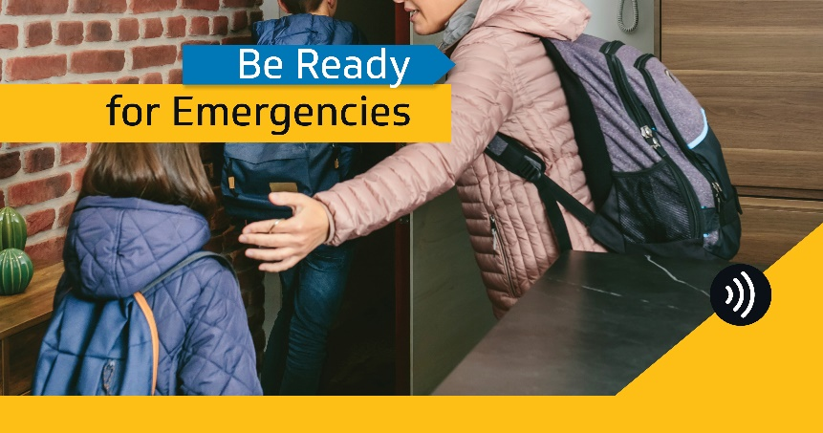
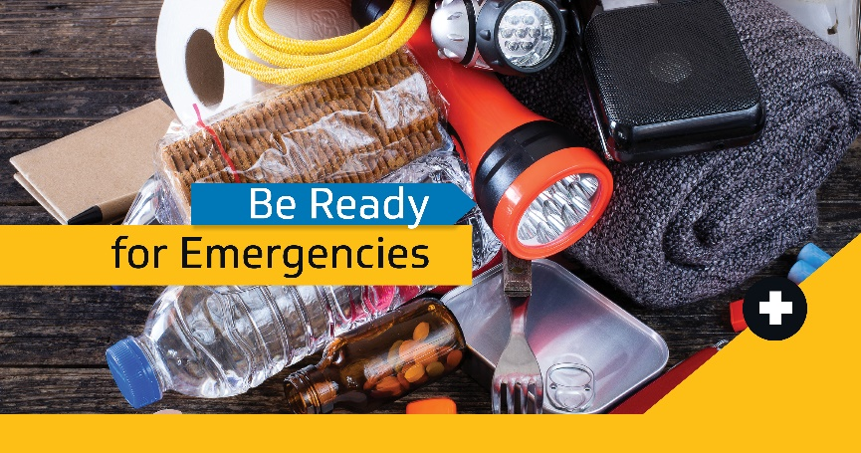

Post text
Know the difference between an evacuation notice, alert & order:
Evacuation Notice: to advise you that an emergency event, such as a wildfire or flood, may present an increased risk to your community and could endanger life or property.
⚠️Alert: You’re at-risk of evacuation. Get emergency supplies and be ready to leave
🚨Order: You are in danger. Leave now.
Understand and plan for evacuations: https://www.maca.gov.nt.ca/en/services/be-ready-emergencies/be-ready-understand-and-plan-evacuations #nwtpoli #BeReadyNWT
Local authorities call most evacuations. Know where to find information:
✔️ Local government website
✔️ Local government social media
✔️ Local radio/TV/online news

Contact your local government for more info on how they will communicate in emergencies. #BeReadyNWT #nwtpoli

NWT Alert

Suggested graphic
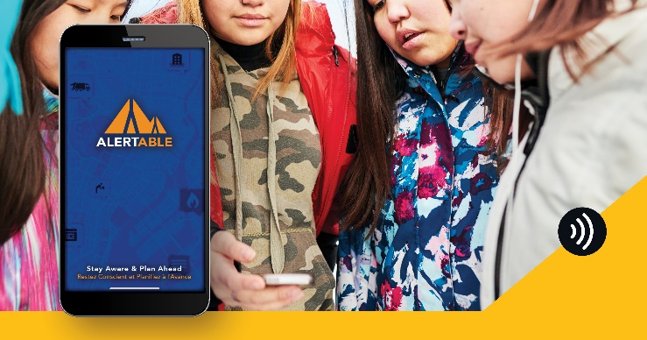

Post text
#NWTAlert pings radio, TV, and cellphones during large emergencies – and tracks most public safety advisories in the #NWT. Stay updated and get notifications to your phone:
🖱️Website: https://nwtalert.ca/
📱Android app: https://play.google.com/store/apps/details?id=com.artermobilize.alertable&hl=en_CA
📱iPhone app: https://itunes.apple.com/ca/app/alertable/id1277488940?mt=8
#BeReadyNWT #nwtpoli

Community radio scripts

For emergency preparation – general

Script 1 – Four Steps to Be Ready for Any Emergency
An important safety message from the [INSERT COMMUNITY GOVERNMENT] and the Government of the Northwest Territories.
Emergencies like floods, wildfires, and power outages happen every year in the Northwest Territories.

If disaster struck and you needed to leave at a moment’s notice, would you be ready?

Our community’s biggest risks are [INSERT YOUR COMMUNITY’S BIGGEST RISKS – EVERY COMMUNITY SOUTH OF THE TREELINE SHOULD INCLUDE WILDFIRE].

Take four simple steps to being ready for any emergency:

- Know the local emergency plan

Check the [INSERT COMMUNITY] website at [INSERT WEBSITE ADDRESS], call [INSERT PHONE NUMBER], or email [INSERT EMAIL] to get information on the community emergency plan.

- Make an emergency plan for your home.

It can take as little as 20 minutes!
Give a copy to every member of your family. If you need help, get checklists online or call [INSERT COMMUNITY GOVERNMENT CONTACT] for help.
- Build your emergency kit

Include the essentials for everyone in your household to last 3-7 days.

- Stay up to date

Learn when you could be in danger and what to do to stay safe. Some good sources include:

- [INSERT THE COMMUNITY GOVERNMENT FACEBOOK/TWITTER/WEBSITE]
- Facebook dot com forward slash Your GNWT
- Local news on TV, Radio, and trusted websites in the NWT.

By taking these steps, you’ll keep yourself, your loved ones, and our community safer.

Get checklists and tips online at gov dot nt dot ca forward slash be ready NWT -- or contact [INSERT CONTACT FOR COMMUNITY GOVERNMENT OFFICE – IF APPLICABLE]

Script 2 – Make an emergency plan
An important safety message from the [INSERT COMMUNITY GOVERNMENT] and the Government of the Northwest Territories.
Emergencies like floods, wildfires, and power outages happen frequently in the Northwest Territories.

Make an emergency plan for your home before danger comes. You and your loved ones will be safer if you do.

An emergency plan should include:

- If possible, 2 ways out of each room of your home in case of fire.
- Emergency exits from your home
- Escape routes for your community.
- Meeting places to get back in touch with family.
- People you trust to take care of your children
- Shelter for pets
- Emergency contacts
- Instructions on how to turn off electricity, gas and water in your house.

Emergencies usually happen with little warning. Plan today so you and your loved ones can be ready when they do.

Get checklists and tips online at gov dot nt dot ca forward slash Be Ready NWT, or contact [INSERT CONTACT FOR COMMUNITY GOVERNMENT OFFICE – IF APPLICABLE]

Script 3 – Build an emergency kit

An important safety message from the [INSERT COMMUNITY GOVERNMENT] and the Government of the Northwest Territories.
Emergencies like floods, wildfires, and power outages happen frequently in the Northwest Territories.

Build an emergency kit so you can be ready with the essentials you need at a moment’s notice when they do.

Here’s a list of items to include:
- About 2L of water per person per day.
- A supply of non-perishable food for all family members and pets to last at least three days.
- First-aid kit.
- Flashlight and extra batteries.
- Wind-up or battery-powered radio and extra batteries.
- Extra eyeglasses or contact lenses.
- Prescriptions or special medications.
- Car keys, credit cards and cash.
- Garbage bags, moist towelettes and sanitation supplies.
- Chargers for cellphones and electronic communication devices.
- Seasonal clothing and footwear for each family member.
Make sure to consider the needs of Elders, people with disabilities, and pets when you make your emergency kit.

Be ready for emergencies: build your emergency kit today. It will keep you and your loved ones safer tomorrow.

Get checklists and tips online at
Gov dot nt dot ca forward slash Be Ready NWT, or contact [INSERT CONTACT FOR COMMUNITY GOVERNMENT OFFICE – IF APPLICABLE]

Script 4 – Understanding the community emergency plan

An important safety message from the [INSERT COMMUNITY GOVERNMENT].
Emergencies like floods, wildfires, and power outages happen frequently in the Northwest Territories.

[INSERT COMMUNITY GOVERNMENT NAME] has a community emergency plan to help everyone stay safer when disaster strikes.

The key points of the emergency plan are where people will go if they need to leave their homes, how you will know when there is danger, and who will be in charge of what during an emergency.

When emergencies happen, we will communicate with you [INSERT THE WAYS YOU WILL COMMUNICATE WITH RESIDENTS – COULD INCLUDE SOCIAL MEDIA ACCOUNTS, POSTERS IN AREAS OF TOWN, DOOR-TO-DOOR COMMUNICATION].

The GNWT may also share updates. Follow them on Facebook at Facebook dot com forward slash Your GNWT.

And follow local news online, community message boards, radio, TV, and newspapers – we will share important information with them when danger is there.

If an evacuation order is given, you and those you live with should meet at [INSERT COMMUNITY MUSTER POINTS -IF APPLICABLE, INCLUDE WHAT KIND OF DISASTERS THEY ARE FOR].

The locations we planned for may not work. They may be made unsafe because of the emergency. So, listen to all directions of local officials and stay tuned into radio.

If you need help – with food, mental health, financial assistance, or physical disabilities, let people at the evacuation centre know.

In an emergency, the community government will coordinate all actions with other agencies like the RCMP and health authorities. We may ask for help from the GNWT if the situation gets beyond our control.

To learn more about the community emergency plan, [SHARE WHERE YOUR COMMUNITY EMERGENCY PLAN CAN BE FOUND – LIKE ON YOUR WEBSITE, OR BY CALLING OR EMAILING THE LOCAL GOVERNMENT OFFICE].

The most important thing to remember is we all need to work together when emergencies happen. That will keep us all safer.

For tips and checklists to help you be ready for any emergency, visit gov dot nt dot ca forward slash be ready nwt.

Script 5 – Understanding evacuation

An important safety message from the [INSERT COMMUNITY GOVERNMENT] and the Government of the Northwest Territories.
Emergencies like floods, wildfires, and power outages happen frequently in the Northwest Territories.

Sometimes, you may be asked to leave your home with very little notice. This is called an evacuation.

Evacuations may be difficult but necessary to keep you, your loved ones, and our community safe.

Here’s how we’ll let you know when to evacuate.

When you are at risk of danger, we will issue an Evacuation alert for your area. This means you and everyone in your household should get ready to leave at a moment’s notice.

Evacuation Orders mean you are in immediate danger. It is time to leave your home and go to the evacuation gathering place. Listen to all directions from local officials – and remember to take your emergency kit with you.

Once you get to the gathering place, register with local emergency officials, and listen to all instructions.

Evacuation alerts and orders are almost always issued by local government but may sometimes be issued by the GNWT if requested or if an emergency is a territorial event.

Find out about evacuation alerts and orders on [LIST HOW YOUR GOVERNMENT WILL TELL PEOPLE ABOUT EVACUATION – LIKE FACEBOOK GROUPS, FACEBOOK PAGES, WEBSITE, DOOR TO DOOR, COMMUNITY RADIO].

Always follow trusted local news sources on radio, TV, and online.

An emergency alert may also be issued on NWT Alert to make sure evacuation alerts and orders go immediately to cellphones, radios, and TV in the high-risk area automatically.

Make sure to talk about the potential for evacuation with people you live with, make a home emergency plan, and build your emergency kit now.

That way, you can be ready when any emergency strikes.

For floods - general

Script 1 – Get Ready for Possible Floods
An important flood safety message from [INSERT COMMUNITY GOVERNMENT NAME] and the Government of the Northwest Territories.

Spring break-up is coming. That means ice jams and floods are a high risk – especially in
[INSERT COMMUNITY NAME – IF YOU ARE ANY OF THESE COMMUNITIES – YOU ARE AT A HIGHER RISK OF FLOODS:
- Hay River
- Nahanni Butte
- Fort Liard
- Fort Simpson
- Aklavik
- Fort Good Hope
- Tulita
- Jean Marie River]
Everyone in our community should consider taking extra steps to protect themselves and their home from flood impacts.

Here are some ideas:
- Keep important equipment off the ground: Raise large appliances, furnaces, hot water heaters, and electrical panels onto wood or cement above the potential water level
- Seal key structures: Apply weather protection sealant around basement windows and the base of ground-level doors
- Use landscaping to protect your home: make sure all water flows away from your foundation. Consider digging trenches for water to fill before it reaches your home.
Floods happen. So, plan ahead and be ready before the water comes.
Get more flood preparation tips and checklists at gov dot nt dot ca forward slash be ready nwt.

Script 2 – How to protect your property from a flood
An important flood safety message from [INSERT COMMUNITY NAME] and the Government of the Northwest Territories.
Floods can force residents from their homes and result in costly damage to personal property for people in the NWT.
Everyone should take these basic steps to be ready as comm rises during spring break-up – no matter where you are.
- Keep valuables safe: Store important items or documents in water-tight containers or in higher places, like on a tall shelf or upper floor
- Keep gutters clear
- Keep foundations clear: keep snow at least 1 to 1.5 metres away from your home's foundation
- Secure your fuel tank: Make sure to anchor any heating oil or propane tanks to the floor or ground. Call your fuel provider for advice. If you rent, talk to your landlord to ensure this is done.
- Secure your water and sewage holding tanks.
Floods happen. Plan ahead and be ready before the water comes.
Find more flood preparation tips at gov dot nt dot ca forward slash be ready nwt.

For floods – risk rising in your area

Script 1 – Get Ready for Flooding Now
Warning: Flood risk is rising in [INSERT COMMUNITY NAME]. Here’s what you can do to stay safe and reduce your risk of damage.
- Keep your cellphone charged to stay connected
- Follow directions from local emergency management officials
- Review your home emergency plan with those you live with
- Make sure your emergency kit is packed with essentials for at least 3 days
- Move valuables at home to higher ground
- Raise appliances on blocks
- Secure your fuel tanks, water and sewer holding tanks
People from the local government will advise you of the latest information using [INSERT HOW YOU WILL COMMUNICATE ABOUT FLOOD RISK AND DANGER – I.E. SOCIAL MEDIA, WEBSITE, DOOR-TO-DOOR, COMMUNITY RADIO].
Be prepared for an evacuation alert to be issued – that means keep your emergency kit in an easy-to-find place and be ready to evacuate at a moment’s notice.
If there’s an evacuation order, grab your emergency kit or pick up a couple of essentials and leave right away. Go to [INSERT THE EVACUATION GATHERING PLACE] immediately.
Use only if you use a flood siren as an alert method
If the water reaches [INSERT MILESTONE – LIKE WATER LEVEL OR LANDMARK IF APPLICABLE] the flood siren will sound.
If you hear it, that means leave right away, and go to [INSERT THE EVACUATION GATHERING PLACE] right away.
Listen to any directions from local officials – they’re here to keep you safe.

We know this is a scary time. But if we all take the right steps, we can keep each other safe.

